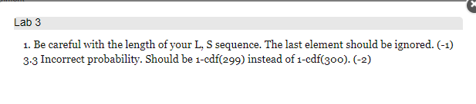

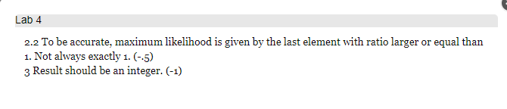

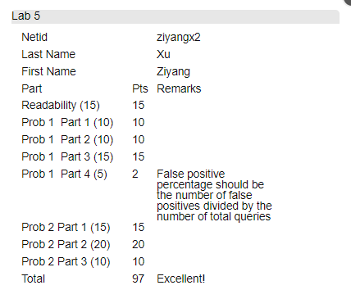

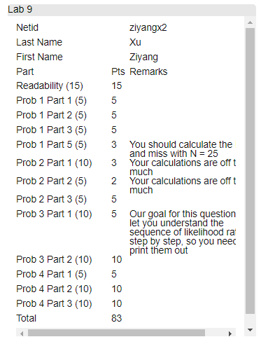

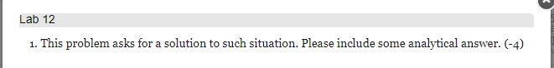

**That’s all. I did not complete and submit the last lab 14, since we can drop one.**